STANDARD FORMAT OF “LEHENGA DESCRIPTION”


For Online Selling Products
Design Name: DREAM-B
Product Colours NO.: B1

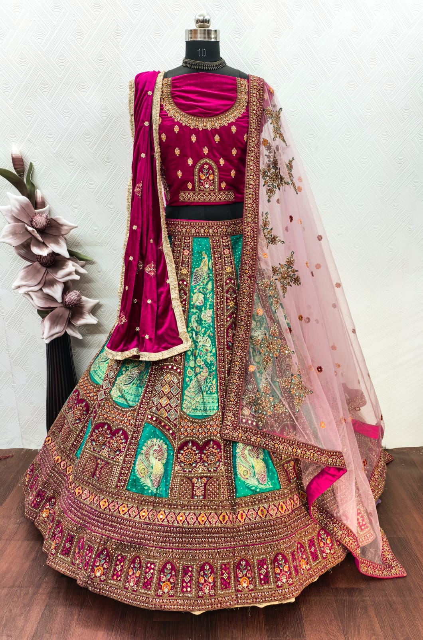
Particulars | Details
Lehenga Fabric | Velvet & Rapier
Blouse Fabric | Velvet with Embroidered Detailing
Dupatta Fabric | Net Dupatta (Big), Velvet Dupatta (Small)
Work Type | Heavy Zari, Jarkan
Colour | Rani
Pattern | Bridal Designer
Stitching Type | Semi-Stitched (Can be customized up to 44")
Occasion | Wedding, Reception, Engagement & Festive Wear
Fit Type | Regular Fit
Care Instructions | Dry Clean Only
Package Contents | 1 Lehenga, 1 Blouse Piece, 2 Dupatta

KEY HIGHLIGHTS
- Crafted from high-quality Velvet & Rapier fabric for a rich finish
- Heavy embroidery adds a luxurious and grand bridal feel
- Dual Dupatta Set: Net dupatta for elegance + Velvet dupatta for royal look
- Ideal for weddings and premium traditional occasions
- Semi-stitched lehenga fits perfectly with alteration flexibility
- Durable craftsmanship designed for long hours of wear
- Available in vibrant bridal shades for a stunning appearance

